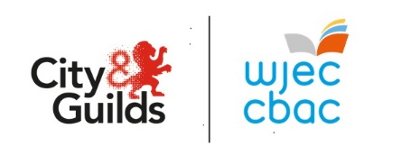

UCAS Points For
WJEC Level 3 Children's Care, Play, Learning and Development: Practice and Theory (First Certification 2025)

A*- 168
A - 144
B - 120
C - 96
D - 72
E - 48

https://www.ucas.com/ucas/tariff-calculator

